LI-FI Technology Using sustainable energy
(New age technology to connect the unconnected)

Abstract— Li-Fi stands for Light-Fidelity. It was proposed by Harald Haas. Li-Fi provides transmission of data through illumination by sending data through an LED light bulb that varies in intensity faster than human eye can follow. Wi-Fi is useful for general wireless coverage within buildings while Li-Fi is ideal for high density wireless data coverage in confined areas where there are no obstacles.it uses light emitting diode. It has better bandwidth, efficiency, availability and security with higher speed. It is a brief explanation of Li-Fi technology, its advantages and its future scopes.
Keywords— VLC, Light-Fidelity, Run length Limited, Giga bytes per second, keying.

Introduction (Heading 1)
Li-Fi, Light Fidelity, is an advanced wireless communication technology that enables data transmission using visible light. Proposed by Harald Haas in 2011, this technology uses LED light bulbs that flicker at speeds which is not seen to the human eye to transmit data. Unlike Wi-Fi, which uses the 2.4-5 GHz radio frequency spectrum, Li-Fi operates within the visible light spectrum, which is 10,000 times wider. Advantages of Li-Fi over Wi-Fi, Li-Fi offers significant advantages in terms of bandwidth, efficiency, and security:
- Capacity: The visible light spectrum is much broader than the radio frequency spectrum, providing immense bandwidth potential.
- Efficiency: LEDs are energy-efficient, consuming far less power compared to the radio masts used for Wi-Fi.
- Availability: Light sources are present in all corners of the world. Hence, availability is not an issue. The billions of light bulbs worldwide need only be replaced by LEDs.
- Security: Light cannot penetrate walls, which makes Li-Fi more secure than Wi-Fi.

LITERATURE REVIEW
The development of Li-Fi technology aims to increase data throughput, power usage, and performance. Li-Fi is a bidirectional network solution that provides a user experience very similar to wi-fi. over time, connectivity requirements will increase dramatically. we need a network with higher spectral capacity to meet these demands. with Li-Fi, we can use a spectrum that is 100,000 times larger than that of radio frequencies. Li-Fi is now capable of delivering unparalleled data and capacity. it is a type of optical radio technology that includes infrared, ultraviolet, and visible light transmission. Li-Fi is distinguished by the fact that the same light energy utilized for lighting might also be used for connectivity. Li-Fi technology is simple but effective. photons are emitted from an led bulb when a continuous current flow is applied to it.

Li-Fi communication technology can function even in direct sunlight since modified light rays may be recognized. Because the system detects quick variations in light intensity rather than the gradual fluctuating levels created by interruptions induced by sunlight, and because light waves in Li-Fi are substantially modulated, the sun just provides a continuous light that the receiver can simply filter out. Li-Fi addresses the problem of radio frequency signal interference due to the vast range of the light wave frequency spectrum. The Li-Fi is vulnerable to interference from other sources such as sunlight and other lights indoors; hence, optical filters should be designed to diminish the DC noise components in the received signal. It is better to use a photodiode in the case of a stationary receiver; still, the imaging sensor is involved instead of a photodiode because of the larger FOV in the case of mobility. Operating imaging sensors is slow and has a high energy intake. For that reason, a suitable balance between the cost, speed and complexity, should be done while considering photodiode and imaging sensors.

METHODOLOGY
Light Fidelity (Li-Fi) technology is wireless communication based on the use of violet (800 THz) and red (400 THz) light sources. Unlike Wi-Fi, which uses the radio spectrum of the electromagnetic spectrum, Li-Fi uses the optical spectrum, which is visible light of the electromagnetic spectrum. The Li-Fi principle is based on the transmission of information in a well-structured way through the change of light. Since LEDs operate in 1 microsecond, LEDs turn on and off faster than the human eye can perceive. This invisible transformation causes data to be converted using binary numbers. If the LED is on, the number "1" is sent; Also, these LEDs can turn on and off very quickly, which gives us a good opportunity to send information through the LED light, since there is no light frequency interference like radio frequency in Wi-Fi. Li-Fi is considered to be 80 more efficient, which means it can reach speeds of up to 1 Gbps and higher. Li-Fi differs from fiber optic because the Li-Fi protocol is designed for short (up to 10 meters) wireless communication. This puts Li-Fi in a unique position for high-speed wireless communication over short distances.

Li-Fi works very simply. At one end is the light emitter, the LED emitter, and at the other end is the photodetector (light sensor). The input data to the LED emitter is encoded into light by the difference between the LED's "on" and "off" flashes (known specifically as visible light communication) to create different sequences of 1s and 0s. The changes in the LED emitter are invisible (the LED's intensity is modulated so quickly that it cannot be seen by the human eye, so the LED's light appears constant to humans), the information is transmitted in the form of light to make it a binary code: turning the LED on means a logic "1", turning the LED off means a logic "0". By changing the value of the LED flashes, the difference between 1s and 0s can be entered into the light as a message. In one configuration, the transmitter (LED) is connected to the data network (connected to the internet via a modem) and the receiver (photodetector/light sensor) eventually receives data in the form of signals and decisions. This data is then displayed on the device connected to the receiver. When the transmitter (LED) is turned on, the receiver (photodetector) will write the binary value "1"; therefore, flashing the LED several times or using a series of LEDs (perhaps in several different colors) will eventually give data rates in the hundreds of Mbps range.

IMAGE TO BINARY

To convert an image into a binary format and transmit it using Li-Fi technology, we can break down the process into key steps, from preparing the image to its transmission and decoding.

Steps for Converting and Transmitting an Image via Li-Fi

1. Resizing the Image: The first step is to resize the image according to the requirements of the hardware being used—in this case, a graphic LCD (GLCD) with a resolution of 128x64 pixels. Reducing the image to these dimensions helps ensure efficient transmission and display compatibility.

2. Converting to Black and White: Convert the resized image into a monochrome bitmap format, where each pixel is represented in black and white. This format minimizes data by encoding pixels as binary values (0 for black, 1 for white). Tools like MS Paint or Python’s PIL library can accomplish this.

3. Processing the Image for Transmission: In MikroC, an image-processing tool converts the monochrome image into a numeric array that holds each pixel's decimal value. This array will serve as the data source for transmission, storing each pixel's on/off state in a format the microcontroller (MCU) can handle.

4. Transferring the Array into Code: Embed the array into the code for the MCU. Once uploaded, the code instructs the MCU to transmit each pixel's value serially over the UART interface.

5. Transmitting the Image via UART: The IR LED, connected to the UART transmitter pin, toggles on and off based on the pixel data. When the LED is on, it transmits a binary '1'; when it’s off, it transmits '0'. The on/off toggling happens faster than the human eye can perceive, effectively transmitting the data as a stream of light signals.

6. Receiving the Image with a Photodiode: A photodiode, positioned to receive the IR signals, detects the LED’s on/off states and sends this data to the MCU as a digital input. The photodiode’s response to the LED’s toggling allows it to convert the light pulses back into binary form.

7. Decoding and Displaying the Image: The MCU decodes the received binary data back into pixel values. These values are then sent to the GLCD,
reconstructing and displaying the original image.

How to counter interference

Li-Fi communication technology can function even in direct sunlight since modified light rays may be recognized. Because the system detects quick variations in light intensity rather than the gradual fluctuating levels created by interruptions induced by sunlight, and because light waves in Li-Fi are substantially modulated, the sun just provides a continuous light that the receiver can simply filter out. Li-Fi addresses the problem of radio frequency signal interference due to the vast range of the light wave frequency spectrum. The Li-Fi is vulnerable to interference from other sources such as sunlight and other lights indoors; hence, optical filters should be designed to diminish the DC noise components in the received signal. It is better to use a photodiode in the case of a stationary receiver; still, the imaging sensor is involved instead of a photodiode because of the larger FOV in the case of mobility. Operating imaging sensors is slow and has a high energy intake. For that reason, a suitable balance between the cost, speed and complexity, should be done while considering photodiode and imaging sensors

Technology used:

1. Light emitter on one end and an LED transmitter photo detector (light sensor) on the other end.
2. Input to the LED transmitter → encoded in to the light (technically referred to as Visible Light Communication) → varying the flickering rate (switching ON -'1', switching it OFF -'0') at which the LEDs flicker ‘on’ and ‘off’ to generate different strings of 1s and 0s.

3. By varying the rate of LEDs flicker on and off information → Encoded in the light to different combinations of 1s and 0s.

4. The transmitter (LED) is connected to the data network
the receiver (photo detector/light sensor) on the receiving end receives the data as light signal.

5. Decodes the information, which is then displayed on the device connected to the receiver.

6. The receiver (photo detector) registers a binary ‘1’ when the transmitter (LED) is ON and a binary ‘0’ when the transmitter (LED) is OFF. Thus, flashing the LED numerous times or using an array of LEDs will eventually provide data rates in the range of hundreds of Mbps

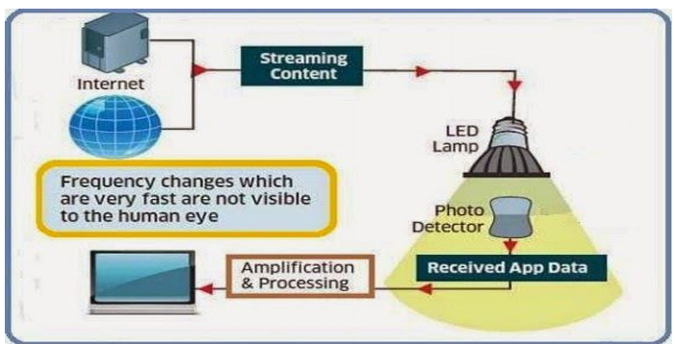

Required - Array of LEDs, a controller (controls/encodes data into those LEDs).
All one has to do is to vary the rate at which the LEDs flicker depending upon the data input to LEDs. By using array of the LEDs for parallel data transmission, or using mixtures of red, green and blue LEDs to alter the light’s frequency, with each frequency encoding a different data channel.
VLC uses the visible light between 400 THz (780 nm) and 800 THz (375 nm) as medium.

Code for Converting an Image to Binary

The Python convert_image_to_binary() function converts any image file (JPEG, PNG, BMP) to a binary representation. Here’s how it works:

Input Parameters: image_path (path to the input image) and output_path (path to save the binary output).

Image Processing: Using Python’s PIL library, the function opens the image and iterates through each pixel. Each pixel's RGB value is then converted to binary using the format( ) function.

Binary Data Creation: The function compiles all binary pixel values into a single data blob.

Saving Binary Output: Finally, it writes this binary data to a specified file in binary mode. This output file can be useful for image compression, data storage, or transmission tasks.

With this method, the image can be efficiently converted, transmitted, and reconstructed using Li-Fi technology, enabling applications in wireless visual data transfer.

Connecting pixel data to a transmitter:

- Data Acquisition and Processing:
Image Capture: Use a camera or other imaging device to capture the image you want to transmit.
Pixel Data Extraction: Extract the individual pixel data from the captured image. This typically involves breaking down the image into its constituent pixels, each represented by a set of colour values (e.g., RGB).
Data Formatting: Format the pixel data into a suitable format for transmission. This might involve compressing the data to reduce its size or encoding it in a specific protocol (e.g., SPI, UART).

- Transmitter Selection and Configuration:
Transmitter Type: Choose a transmitter that is compatible with your pixel data format and transmission requirements. Common options include:
- RF Transmitters: Suitable for wireless transmission over short to medium distances.
- Wi-Fi Modules: Ideal for wireless transmission over longer distances and networks.
- Ethernet Modules: For wired transmission over Ethernet networks.
- Serial Transmitters: For point-to-point serial communication.
Configuration: Configure the transmitter's parameters, such as data rate, modulation scheme, and power output, to match your specific needs.

Data Transmission:
Data Input: Connect the formatted pixel data to the transmitter's input pins or data bus. This might involve using digital-to-analog converters (DACs) to convert the pixel data into analog signals, or directly interfacing with digital transmitters.
Transmission: Initiate the transmission process. The transmitter will encode and modulate the pixel data and send it over the chosen medium (e.g., RF, Wi-Fi, Ethernet).

Specific Considerations:

Pixel Data Rate: The data rate required to transmit the pixel data will depend on the image resolution, color depth, and frame rate. The transmitter must be capable of handling this data rate.
Transmission Distance: The distance over which the data needs to be transmitted will influence the choice of transmitter and its power output.
Noise and Interference: Consider the potential for noise and interference in the transmission environment and choose a transmitter with appropriate modulation and error correction techniques.
Power Consumption: The power consumption of the transmitter and any associated circuitry should be taken into account, especially for battery-powered devices.
Security: If security is a concern, consider encrypting the pixel data before transmission.
Example: Using a Microcontroller and RF Transmitter

Capture and Process Image: Use a camera sensor or image processing hardware to capture and process the image.
Format Pixel Data: Convert the image data into a serial stream of bytes, suitable for transmission.
Microcontroller Interface: Connect the microcontroller to the camera sensor or image processing hardware to receive the formatted pixel data.
RF Transmitter Interface: Connect the microcontroller to the RF transmitter using appropriate protocols (e.g., SPI, UART).
Transmission: Use the microcontroller to control the RF transmitter and send the pixel data over the wireless channel.

ADVANCE YECHNIQUES

Modulation Techniques:

Amplitude Shift Keying (ASK): Simple but susceptible to noise.
Frequency Shift Keying (FSK): More robust to noise but less efficient.
Phase Shift Keying (PSK): More efficient but requires more complex hardware.
Quadrature Amplitude Modulation (QAM): Highly efficient but sensitive to noise.

Error Correction Codes:

Hamming Codes: Simple but effective for correcting single-bit errors.
Reed-Solomon Codes: Powerful for correcting multiple-bit errors.
Turbo Codes: Highly efficient and widely used in modern communication systems.

Antenna Design:

Antenna Gain: Higher gain antennas can improve transmission range and signal strength.
Antenna Diversity: Multiple antennas can improve reliability and diversity gain.
Antenna Polarization: Proper polarization matching can enhance signal reception. Power Management:

Power-Saving Modes: Devices can enter low-power modes when not actively transmitting or receiving data.
Energy-Efficient Hardware: Low-power components can reduce power consumption.

SPECIFIC HARDWARE AND SOFTWARE CONSIDERATIONS
Microcontrollers: Arduino, Raspberry Pi, or specialized microcontrollers can be used for data processing and transmission.
Wireless Modules: Wi-Fi, Bluetooth, Zigbee, LoRa, or cellular modules can be used for wireless communication. Image Processing Libraries: OpenCV, Pillow, or other libraries can be used for image processing and compression.
Communication Protocols: TCP/IP, UDP, MQTT, or other protocols can be used for data transmission.

CODE:
import os
from PIL import Image

def convert_image_to_binary(image_path, output_path):
"""
Converts an image to a binary representation and saves it to a file.

Parameters:
image_path (str): Path to the input image file.
output_path (str): Path to save the binary output file.
"""
# Open the image
image = Image.open(image_path)

# Convert the image to binary
binary_data = b''.join(format(pixel, '08b') for pixel in image.getdata())

# Save the binary data to a file
with open(output_path, 'wb') as file:
file.write(binary_data)

print(f"Image converted to binary and saved to: {output_path}")

PROCESSING IDE CODE:

import processing.serial.*; // Import the serial library
Serial myPort; // Create a Serial object

int [][] receivedImageData = new int[32][32]; // Array to store received bits for the image
int row = 0, col = 0; // Track the current position in the grid

void setup() {
size(320, 320); // Window size (each pixel is 10x10 for 32x32)
myPort = new Serial(this, "COM3", 115200); // Open serial port, adjust to your port name
myPort.bufferUntil('\n'); // Read data until newline character
}

void draw() {
background(255); // Clear the screen

// Draw the 32x32 image grid
for (int i = 0; i < 32; i++) {
for (int j = 0; j < 32; j++) {
if (receivedImageData[i][j] == 1) {
fill(0); // Black for "1" (LED ON)
} else {
fill(255); // White for "0" (LED OFF)
}
rect(j * 10, i * 10, 10, 10); // Draw each "pixel" as a 10x10 rectangle
}
}
}

// This function is called whenever serial data is available
void serialEvent(Serial myPort) {
String inputLine = myPort.readStringUntil('\n'); // Read until newline

if (inputLine != null) {
inputLine = inputLine.trim(); // Remove any whitespace

// Check if the line has the expected 32 characters
if (inputLine.length() == 32) {
for (int i = 0; i < 32; i++) {
receivedImageData[row][i] = Character.getNumericValue(inputLine.charAt(i));
}
row++;

// Reset row count after filling the entire 32x32 grid
if (row == 32) {
row = 0; // Reset to start at the top row
}
}
}
}

RECEIVING SIDE ARDUINO CODE:

const int photoPin = A0; // Photodiode pin
int threshold = 500; // Adjust based on calibration
int highFrequencyDetected;

void setup() {
Serial.begin(115200); // Start Serial communication
}

void loop() {
highFrequencyDetected = 0; // Reset detection flag

// Sample the photodiode signal multiple times to detect 1 kHz modulation
for (int i = 0; i < 100; i++) {
int lightValue = analogRead(photoPin);

// Check if signal is above the threshold
if (lightValue > threshold) {
highFrequencyDetected++;
}

delayMicroseconds(500); // Sample at 1 kHz intervals
}

// Interpret as "1" if high frequency was detected frequently enough
if (highFrequencyDetected > 50) { // Adjust this threshold based on testing
Serial.print("1");
} else {
Serial.print("0");
}

delay(10); // Adjust delay based on your data rate
}

WORK DONE
1. Research Phase:
- Literature Review: Conducted an extensive review of existing Li-Fi technologies, their applications, and limitations, particularly in rural areas.
-Needs Assessment: Identified the specific connectivity challenges faced by rural regions, such as lack of infrastructure and high costs of traditional internet services.

2. Concept Development:
- Transmitter and Receiver Models: Designed models for the Li-Fi transmitter and receiver, selecting appropriate light sources (e.g., LEDs) and photodetectors to optimize data transmission.
- Propagation Medium: Explored the use of visible light as a medium for data transmission, considering factors like range, interference, and environmental conditions.

3. Encryption Technology:
-,High-Level Encryption: Developed a robust encryption protocol to ensure secure data transmission, addressing potential cybersecurity threats specific to wireless communications.

4. Simulation and 3D Modeling:
- 3D Model Creation: Utilized software tools to create a detailed 3D model of the Li-Fi system, illustrating the configuration of the transmitter, receiver, and the physical layout for deployment.
- Simulation Testing: Conducted simulations to evaluate the performance of the Li-Fi system under various conditions, analyzing parameters like data rate, range, and interference.

5. Proof of Concept:
- Functional Prototype: Developed a proof-of-concept model to demonstrate the feasibility of the Li-Fi system. This included testing the transmitter and receiver in controlled environments to validate performance metrics.
- Field Testing Plans: Formulated a plan for field testing the prototype in real-world rural environments, considering logistical challenges and community engagement.

MODEL
We used Tinkercad to create a 3D model of the Li-Fi system, showcasing the transmitter and receiver setup along with the physical deployment layout.

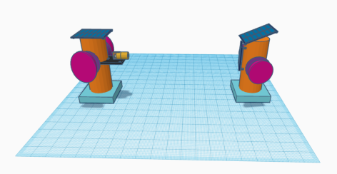

Demo Site Informations

- 20°09’37”N 85°40’08”E 67m

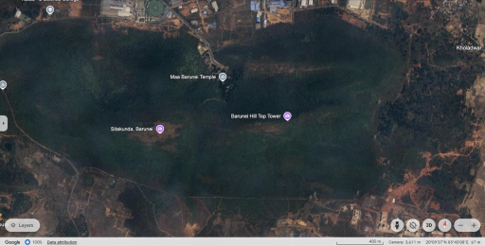

- 20°09’37”N85°39’45”E 87m

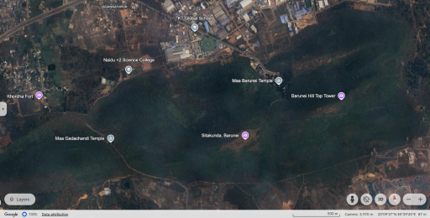
- 20°08’35”N 85°38’32”E 68m

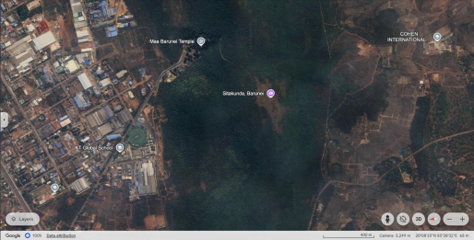

- 18°22’28”N 81°54’26”E 505m

- 21°29’16”N 84°26’33”E 406m

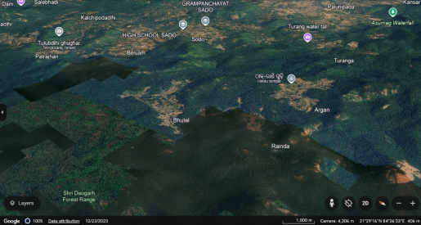

CONCLUSION

Li-Fi technology stands as a promising alternative to traditional radio-based communication systems. With the ability to transmit data through LED light sources, Li-Fi not only addresses the limitations of radio frequency bandwidth but also paves the way for faster, more secure, and environmentally friendly communication networks. As development continues, Li-Fi is expected to integrate seamlessly with existing wireless solutions, creating a more efficient and ubiquitous network platform. This innovation promises to revolutionize data transmission, with potential applications ranging from high-speed internet access in congested areas to safer traffic management and assistance for visually impaired individuals. While technical challenges, such as optimizing modulation techniques, remain, the advancements in Li-Fi suggest it could soon play a crucial role in global connectivity, driving forward a new era in wireless communication systems.

References

- Anurag Sarkar, Shalabh Agarwal and Asoke Nath "Li-Fi Technology: Data Transmission through Visible Light", article in International journal of Advance research in computer science and management, July 2015.
- Omar Faruq, Nusrat Jahan, Kazi Rubaiyat Shahriar Rahman, Sakib Rokoni and Mosa Rabeya "Li-Fi technology based long range free-space communication data transmit system evaluation", April 2023
- Behzad Razavi "RF Transmitter Architectures and Circuits"
- Monica Leba, Simona Riurean, Andreea Ionica "LiFi – the Path to a New Way of Communication"
- Devi Ganesan, Gokul Raghavendra Srinivasan "A critical review on Li-fi Technology and its future applications", March 2023

